STATEMENT OF PURPOSE
Contents
Who we are: 2
Limitless Homes and Support 2
Always an Alternative 2
What we do: 3
Our approaches: 5
Student Centred Supported Learning (SCSL) 5
Support 5
Relevant Learning 6
Activity Based Learning 6
Self-Reflection 7
Measuring outcomes 7
Learning with us 7
Our sessions 7
Maths 8
English 8
PHSE 8
1TEN Mindset 9
Knife Crime & Youth Violence 9
Gang Culture 9
Child Criminal Exploitation (CCE) 9
County lines 9
Child Sexual Exploitation (CSE) 10
Grooming 10
Anger management 10
Conflict resolution 10
Confidence 10
Identity 10
Financial literacy 10
How to be an entrepreneur (making a business) 11
ASDAN 11
Safeguarding 11
Transitions 11
Our values 13
Take a look inside 14
Contact us: 15

Who we are:
Project X is an innovative Alternative Provision that provides a unique and effective combination of education and mentoring for students aged 11 – 16 years of age who are at risk of being expelled or permanently excluded from school.
This new prevention service is a collaboration between Limitless Homes and Support and Always an Alternative.

Limitless Homes and Support
Limitless Homes and Support hold many years’ experience of working with young people who are Looked After Children, in need of tailored support and who require accommodation and support to enable them to live independently upon reaching 18 years of age.
“We are tenacious, resilient, nurturing and empowering in the delivery model, giving hope and opportunities to young people who require support to live independently”
Limitless Homes and Support offer a different approach when supporting young people in our homes. Our projects are established to represent family living; there are routines, boundaries and rules to follow. The Team are recruited for their ability and skills to be compassionate, supportive, nurturing and firm but fair with young people. We all hold the ethics that we treat young people with the same ethics as we do our own family members; with respect, care and importance. Our staff team adopt therapeutic approaches used to achieve positive mindsets and alternative ways of thinking with our young people. Our approaches include Cognitive Behavioural therapy (CBT), trauma informed practice and the signs of safety model.

Always an Alternative
Always an Alternative was born out of the Anti-Knife Crime Campaign; Keep Sheffield Stainless.
Keep Sheffield Stainless was established in 2017 by Anthony; Always an Alternative founder. Keep Sheffield Stainless focus was to prevent as many knives as possible from being in our communities and in the hands of young people; ultimately reducing knife crime. This was made possible by introducing England's first ever portable weapon amnesty bin, delivering workshops on knife crime and actively taking weapons from the streets; named weapons collections. We now have 8 weapon amnesty bins throughout South Yorkshire and have removed over 300 weapons from the streets.

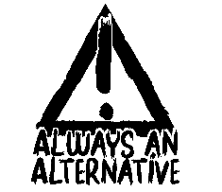
However, after working with young people, communities and professionals it was found that the knife was the end product of behaviours that manifested due to other issues such as peer pressure and the need to feel safe. Ultimately, the mindset of the young people needed to be challenged; not only around knife crime but other topics such as: serious youth violence, Child Criminal Exploitation (CCE), Child Sexual Exploitation (CSE), substance misuse, Self-Esteem and role models.

The aim; to enable young people to see their new found ability to seek out positives in their life and aspire to be the best version of themselves. This is delivered in full workshops, 121 sessions, mentoring and training and development for professionals.

Always an Alternative is regularly covered in the local and national news for its efforts around tackling knife crime, serious youth violence, educating and mentoring young people around its effects.

We want our students to return back to mainstream school wherever this is possible. This outcome is made clear throughout the young person’s learning journey and this is an expectation and objective we are all working towards.

All teachers, support staff and mentors share a commitment to continued professional development. Such that the delivery of support and curriculum and all aspects of young people’s experience, both academic and social is informed by an understanding of each pupils’ strengths and weaknesses, maximising their self-belief and progress.

What we do:
We support our young people to be the best version of themselves by delivering tailored support to help them achieve their goals and realise their aspirations. We support young people to overcome the barriers of learning and achieving success posed by specific learning and language difficulties, and associated difficulties. We adopt a Student-Centred Supported Learning approach to engage, educate and enable our students to understand their way of learning and their own learning styles and think realistically about their futures.
We specialise in delivering sessions to young people who are involved in, or who are at high risk of becoming involved in serious youth violence. We work with young people using modalities such as Cognitive Behaviour Therapy (CBT) and Neuro-linguistic programming (NLP) to develop strategies with the young person to enable them to reach their personal and educational goals.
Ensuring the young person is at the centre of everything we do means that the young person has a meaningful input into their education preferences, such as learning styles, choice-based curriculum and what their goals are, not only whilst they are with Project X but that can be implemented and built upon in future. We believe that persistency and nurturing is the key to our success with young people.
Our ethos is to explore every possible avenue to ensure we never have to give up on any of the young people we support. This requires, tenacity and resilience in staff, alongside genuine care and concern for the wellbeing of young people accessing our support.

We achieve this by working with our many partners in the community such as other alternative provisions, other professionals who are involved with the young person, local businesses, statutory organisations and community initiatives.

We take our students through the process of allowing them to realise their potential before exclusion or during exclusion as well as educating them around the decisions they make as a young person can and will impact their future as an adult. Our aim is to enable the young person to find their own route they wish to take in life and empower them to improve their attitude to learning and create a tailored programme to suit their needs.
“Educating them around the decisions they make”

Our approaches:

Student Centred Supported Learning (SCSL)
Student
Centred
Supported
Learning
Our students are at the heart of every decision made. We allow our students to make choices about their own learning, supported by all involved professionals.

Our SCSL approach ensures that learning is personalised; we create a tailored programme of support for the young person and understand their learning needs and style. This is recorded in the young person’s needs assessment.
We take the opportunity our SCSL approach offers, to enable young people to take greater responsibility for their education by ensuring all learning is competency based and supported by our tutors. Self-reflection is key to success and is conducted weekly with students, tutors and support staff.

Support
We understand the complexities that surround students as they grow in to adults both inside and outside of education. Therefore, it is of high priority that we not only educate students but support them along their journey in an educational setting and at home where possible. This high level of support is achievable by not only engaging with students but working closely with schools, parents and all other professions.
As seen in the diagram below, ourselves; the school; the parents and other professionals will work together to safeguard our students. All professionals will offer support and guidance to our students, allowing them to make an informed decision by themselves (where this is appropriate).

Relevant Learning
Our approach to learning is an innovative approach by keeping Maths and English from the current curriculum. However, we teach our subjects in current relevant terms. The core of our sessions are built around PSHE and are taught in a way that is relevant to current affairs and relevant issues which young people may face. Our bespoke sessions are built around new issues that have not yet made it to the curriculum such as (but not inclusive of) knife crime, county lines, independent living and the impact of technology, including social media.

Activity Based Learning
Activity based learning compliments our PSHE learning. We find that young people respond extremely well when we break up lessons with practical activities. Young people are offered opportunities to work with our many partners such as creative writers, podcasters, music producers, graffiti artists, football coaches, business owners plus many more! We pride ourselves on being a versatile project that goes over and above for the young person to enable them to find something they are interested in and skills they would like to develop further.

Self-Reflection
Self-reflection is key to success and is conducted weekly with students, tutors and support staff. Our self-reflection sessions are purposely time limited, regular and supportive to reassure our young people their voice is central to improvement and their own positive experiences. This learning can be applied inside and outside of the young person’s study environment.

Measuring outcomes
Outcomes are measured in terms of hard and soft outcomes; this is to ensure the young person can see a visual representation of their whole learning journey.
“The young person can see a visual representation of their whole learning journey. “
Our hard outcomes are definable and measurable, e.g. achieving a certain level of learning, grade or coursework.
Soft Outcomes are less tangible and more difficult to measure, such as increased self-esteem, self-confidence and problem-solving abilities.
Project X measure outcomes loosely based on the Outcomes Star. Our outcomes are underpinned by three values; Engage Educate Enable. Our outcomes are informed by adopting Student Centred Supported Learning, strengths based and co-production approach, ensuring the young person’s voice is at the centre of every decision made.

Learning with us
Our programmes are available in term time, Monday – Friday, 9:30 – 15:00. 1:1 Mentoring sessions are available outside of these hours.

Our sessions
sessions include:
- *Maths (Functional Skills/ GCSE) | - *English (Functional Skills/ GCSE)
- *PSHE | - Mindset
- Knife crime | - Gang culture
- CCE | - County Lines
- Grooming | - CSE
- Anger management | - Conflict resolution
- Confidence | - Identity
- Financial Literacy | - Creating a business
- Anti-Social behaviour | - Equality and diversity
- Mental Health | - Staying safe
- Over 50 accredited ASDAN courses
*Subjects from the school curriculum.

Maths
We will work with students and support them to obtain the highest possible level achievable (GCSE). This is completed by using real world scenarios enabling them to understand maths in a more relevant context and gain transferrable life skills: fitting shelves to understand angles, figuring out sales prices to allow them to understand percentages etc.

English
We will work with students and support them to obtain the highest level achievable (GCSE). Creativity and technology will allow students to enjoy reading and writing. For example, students are taught how to write emails and letters and how to conduct themselves online.

PHSE
Topics include:
- Business and enterprise | - Career options
- Employability | - Further education
- Managing finances | - eSafety
- Understanding and managing risk | - Substance and alcohol misuse
- Making health choices | - Mental and emotional health
- Physical health | - Puberty
- Personal identity | - Relationships
- Sexual health | - Diversity
- Democracy and justice | - Rights and responsibilities

1TEN Mindset
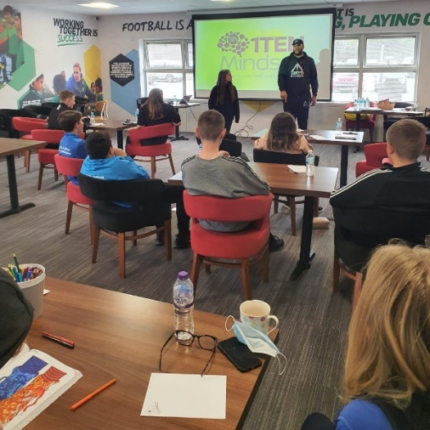
Everyone can put 100% into their goals, sometimes this won’t be enough. The extra 10% could be pivotal point to reaching your goals. The 1TEN Mindset (110%) is the foundation for all of the sessions. It allows students to look at the world differently and give them self-belief and confidence to make and set goals and complete them successfully.

Knife Crime & Youth Violence
Many people know that knife crime is a growing problem, but this session brings the severity into perspective. Students will find out about victims and the consequences of knife crime and other offences by hearing from a rehabilitated offender. Students will also explore Facts and Stats around Knife Crime, the impact of receiving a criminal record, plus many more insights around consequences.

Gang Culture
We look at:
- The different routes into a gang
- What distinguishes gangs
- How young people are affiliated with gangs (tattoos, colours, signs)
- Music and its influences on young people, paying attention to slang words
- Common criminal activities undertaken by gangs and the consequences of being caught and convicted

Child Criminal Exploitation (CCE)
This session looks at:
- Why young people are targeted to commit criminal activities
- How young people are lured into those criminal activities
- What happens once you are associated with a gang and how you get out of one

County lines
We look at the techniques organised crime gangs use to coerce young people and vulnerable adults.
- The warning sign of county lines
- Ways to decline offers that may lead to county lines. The truth around county lines.
- Case studies from victims of county lines

Child Sexual Exploitation (CSE)
We explore the signs of:
- Previous case studies
- How to stay safe
- How to report and escalate concerns

Grooming
We look at what grooming is.
- The different types of grooming
- The reasons why perpetrators may use grooming
- What to do if you feel you are being groomed

Anger management
We delve into how the brain works.
- Look at why we get angry and react the way we do
- Looking at Cognitive Behaviour Therapy (CBT) techniques, understand how we can change the way we normally act when we get angry

Conflict resolution
We look at what different types of conflict is:
- What can cause conflict
- Stages of escalation
- Discuss techniques of de-escalation which can be used to resolve conflict.

Confidence
We explore different ways that students can become more confident.
- We look at the opportunities acting confident can bring
- How stepping out of comfort zones benefit those who lack confidence and self-esteem.

Identity
We consider.
- Who are we?
- Where we feel that we are welcomed
- Students think about where they come from; their family, friends, environment
- We explore ways which students can describe their identity and belonging.

Financial literacy
We explore financial skills set:
- What is personal financial management
- What is budgeting, and investing
- Understand how to become financially stable

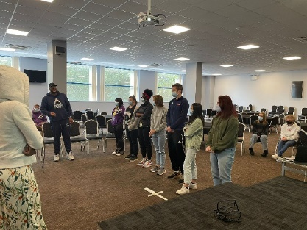
How to be an entrepreneur (making a business)
The idea, market research, creating a brand, choosing the right business structure, the legalities, we cover it all. Students are encouraged to write a business plan to put in to action.

ASDAN
Students have a choice of over 50 accredited courses to choose from to allow them to get them ready to learn independently.
Some of our lessons are complimented by visiting speakers, off site visits and tailored support.

Safeguarding
Project X service delivery in underpinned by the robust implementation of policies and procedures. Project X safeguarding policies are developed to mirror the local authorities reporting and escalation procedure. Our Safeguarding Policy encompasses Children, Adults, CSE, CCE and Domestic Abuse. A full list of our policies is available upon request.
Project X is available for young people who are in Key Stage 3 and Key Stage 4.
Young people who are referred to Project X are assessed for a place at our project by way of identifying the young person’s supports and educational needs, how we manage any previous behaviours and triggers, how appropriately students match with existing young people within the project and the needs and wishes of the young person who requires a place within the project.

Transitions
Students have a clear goal path when they are enrolled, this includes:
- Goals setting around their weekly and term time schedule
- Longer term goals setting around returning to school.
- We ensure the young people are settled back into school by developing a planned transition with them; hand holding them from project back to school to ensure stability, continuity and reassurance.

Our young people leave Project X and have developed a broader understanding of and promote views and experiences around our multicultural, international society and are more resilient learners who are autonomous and independent.

Our values

ENGAGE
We engage with and include young people throughout their journey with us to enable a trusting relationship to be formed.
EDUCATE
We educate young people on every day social skills and awareness of new issues they may face and on maintaining a positive mindset; thinking about their decisions and taking time to consider their actions.
ENABLE
We enable young people to see their value and unlock the door to their full potential through tailored support and education.

Take a look inside
Study room (6 student maximum)
Full of useful information and colour; students get the opportunity to show case their work on our displays.

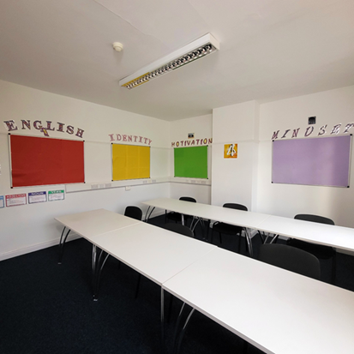 | 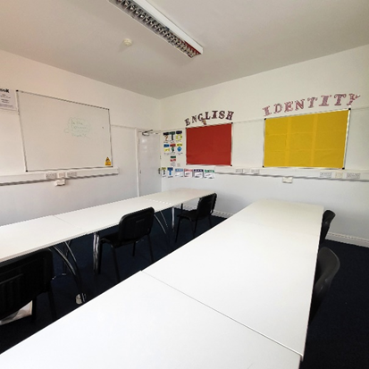
Break out room  Have a sit down and a drink or play on a games consle this room is the place to relax. | Vinyl printing  T-shirts, hoodies or cups. We will show our students how to create and express their identity.
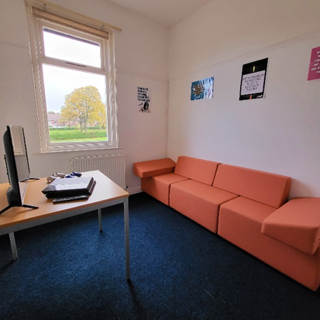 | 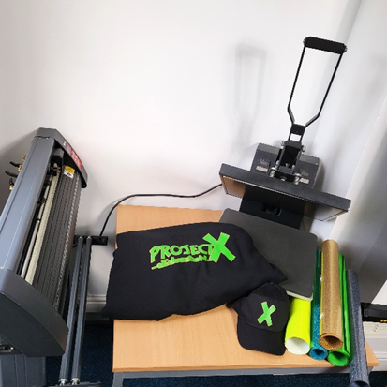

Green Screen  Whether it is a flim or a picture students are amble to place them selves any where they like with our green screen facilities. | Recording station  Rapper, poet or podcast host. Our students will be taught how to express their thought and feelings a creative way.
 | 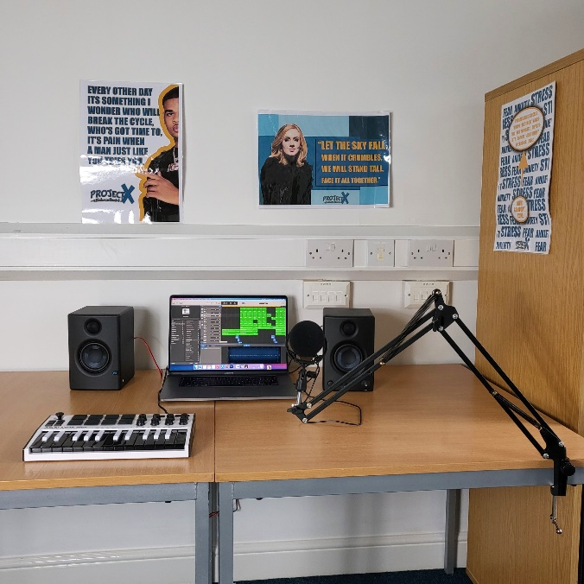

Contact us:
41 Southey Avenue
Longley
Sheffield
S5 7NN
www.projectx.education
info@projectx.education
0114 1314862
07436468327 / 07563580954

